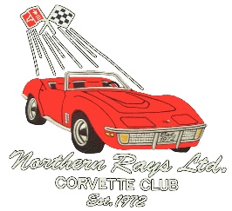
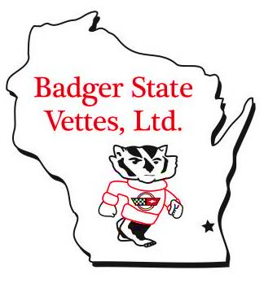
CAR # _______________ (Registration use only)
BADGER STATE VETTES & NORTHERN RAYS LTD.
DOUBLE GIMMICK & DOUBLE POKER RALLYE ~~ May 15, 2016
Make checks payable to Badger State Vettes & mail in time to be received by May 9, 2016 to receive Pre-registration prices: Badger State Vettes ~ P O Box 61 ~ Muskego WI 53150-0061

54
ENTRY FEE: PRE-REGISTRATION $30 Cash Check #
ENTRY FEE: DAY OF EVENT $40 Cash Check #
Car Year & Make:
Car License # State:
Driver’s License #: State: checked
Current NCCC card: Driver checked Navigator checked
Driver: NCCC #:
Address: Club Name:
City: State: Zip: Phone: ( )
If you want your results e-mailed, please provide e-mail address:
Navigator: NCCC #:
Address: Club Name:
City: State: Zip: Phone: ( )
Whom do you wish to notify in case of Emergency? (Leave blank if a member of your Club, at the event, will act as your contact person.)
Name: Relationship: Phone: ( )
By registering, I agree to allow Badger State Vettes, Ltd. to use any image of my vehicle or myself for display on the Badger State Vettes, Ltd. website.
Before being allowed to start a Rallye, all vehicles MUST be inspected to see that they comply with state and local vehicle regulations. Tech inspection includes the following:
Headlights Windshield Wipers
Turn signals Steering
Tail lights Seat Belts – driver & navigator
Brake lights Rear View Mirror
Back-up lights (if equipped) Horn
Brakes Valid Driver's License for Driver
Tires - 2/32 inch minimum tread Current Vehicle License Plate
(No visible cords)
MUST have working odometer for Rallye if mileage is a factor in scoring
Tech Inspector's Initials:
Any vehicle that, in the opinion of the tech inspector, would constitute a danger to life and limb will not be allowed to enter and the driver shall be refunded the entry fee.
Postmark Date: Date Received: Check # Total of Check: $

